The Smithsonian Institute Database

Conceptual Design and Logical Relational Schema

Craig Parry and Jon Sykora

March 13th, 2021

**Contents**

**1 The Smithsonian Institute (TSI)** **3**

2 Conceptual Schema of the Database **3**

2.1 Entities 3

2.2 Relationships 5

2.3 Explicit Integrity Constraints 6

**3 Example Queries** **8**

**4 The Logical Relational Schema (LRS) for the TSI database** **9**

4.1 Additional Integrity Constraints for the relational schema 10

### 

### **1 The Smithsonian Institute (TSI)**

The purpose of the database is to store the information of The Smithsonian Institute (TSI) regarding museums, zoos, research centers, cultural centers, education, and general information about the organization. The database will provide access to information about the Smithsonian's resources to researchers and the public. Users of the database include members, researchers, educators, students and the general public for the purpose of education, research and preservation of history, culture and science. The database should include information regarding its properties (museums, galleries, gardens, the zoo, research centers, and cultural centers), details of those properties (physical addresses and directions, visit details and current restrictions, maps and floor plans), assets of properties (cultural, historical and scientific artifacts), education initiatives, current events at a specific component of the TSI, membership details, donation details, current members and their details, statistical information about the members, statistical information about TSI, and visitor statistics.

TSI is the world's largest museum, education and research complex, managing 19 museums, galleries, gardens and the National Zoo. A person may become a member of TSI, donate or visit TSI’s properties for general admission, an event, an exhibition or to participate in an educational initiative. TSI keeps track of statistics that record membership, donation and visitation data.

This document will further describe the conceptual design of the database and its constraints. Section 2 covers the definition and description of entities, relationships and their attributes, as well as provides explicit integrity constraints and an Extended Entity Relationship Diagram describing the conceptual design. Sections 3 provides example queries that the database can accommodate.

### **2 Conceptual Schema of the Database**

The order of presentation of the conceptual schema is:

1. Entities: description and attributes
2. Relationships: description and attributes (if applicable)
3. Explicit Integrity Constraints
4. Extended Entity Relationship Diagram (EER Diagram)

#### **2.1 Entities**

The entities defined for this database are:

* COMPLEX
* PROPERTY
* COLLECTION OBJECT
* PERSON
* MEMBER
* EVENT
* EXHIBITION
* EDUCATION INITIATIVE

A detailed description of each entity follows.

**COMPLEX:** A managing body of museums, galleries, gardens, zoos, research and cultural centers with the purpose of preserving significant artifacts, expanding research and education. For the purpose of this database there will be one instance of this entity, The Smithsonian Institute.

Attributes: ComplexName (SSPF)

ComplexAbout (SSPF)

Publications (pubname, pubdate, author) (CMPF)

**PROPERTY:** An institution, facility or space. The PROPERTY subtypes are represented by the attribute PropertyType that represents a subtype of the superclass PROPERTY. The attributes inherited for all subtypes are all the same as the superclass and to improve the readability of the EER we chose to not include the visual depiction of the subtype entities.

Attributes:PRName (SSPF)

PRDescription (SSPF)

PropertyType (SSPF)

VisitInfo (SSPF)

PRLink (SSPF)

PRAddress (PRstreet,city, state) (CSPO)

Highlights (SSPO)

Map (SSPO)

Floorplan (SSPO)

Directions (transportation, parking) (CSPO)

Dining (EstablishmentName, PRdescription) (CMPO)

CurrentRestrictions (SSPO)

Accessibility (SSPO)

**COLLECTION OBJECT:** An object, artifact, or item owned by a TSI property, or showcased at an exhibition. The COLLECTION OBJECT subtypes are represented by the attribute ObjectType that represents a subtype of the superclass COLLECTION OBJECT. The attributes inherited for all subtypes are all the same as the superclass and to improve the readability of the EER we chose to not include the visual depiction of the subtype entities.

Attributes: ObjectRecordID (SSPF)

ObjectName (SSPF)

ObjectType (SSPF)

ObjectDescription (SSPF)

ObjectKeywords (SMPF)

**PERSON:** A person is super class describing a person that exists by interacting with COMPLEX through one of its components.

Attributes: PEName (FirstName, LastName) (CSPF)

PEAddress (Perstreet, city, state, postalcode) (CSPF)

EmailAddress (SSPF)

Payment (credit card, expiration, seccode) (CSPF)

**MEMBER**: A type of person who is a member of COMPLEX. This entity is a subclass of the PERSON

entity. This entity contains the additional attribute MemberLevel.

Attributes: MemberNumber (SSPF)

MemberLevel (SSPF)

**EVENT:** A talk, tour, performance, or other event sponsored by a COMPLEX property.

Attributes: EVNumber (SSPF)

EVName (SSPF)

EVDate (SSPF)

Location (SSPF)

AdmissionCost (SSPF)

CoSponsor (SSPO)

Venue (SSPO)

EVDetails (SSPO)

Note (SSPO)

EVLink (SSPO)

**EXHIBITION:** A public display of works of art or items of interest, curated by a COMPLEX property. This entity is a subclass of the EVENT entity.

Attributes: EXDescription (SSPF)

EXNumber (SSPF)

**EDUCATION INITIATIVE:** an educational goal that is pursued by COMPLEX properties by organizing educational events and exhibits

Attributes: EDName (SSPF)

EDDescription (SSPF)

#### **2.2 Relationships**

The relationships in this schema are listed and described below.

**manages:** COMPLEX manages the operation of any PROPERTY included in the complex.

No attributes.

**donation:** A person can make a donation to COMPLEX.

Attributes: AmountDonated (SSPF)

**visits:** A person can visit COMPLEX properties.

Attributes: VisitDetails (CMPF)

**owns:** COMPLEX owns assets, items or objects that may be stored at a PROPERTY.

No Attributes

**displays:** An EXHIBITION displays a COLLECTION OBJECT.

No Attributes

**instructs:** COMPLEX instructs educational initiatives that are coordinated with their properties.

No Attributes

**sponsors:** COMPLEX sponsors events that are held at COMPLEX properties.

No Attributes

**membership:** A PERSON is a MEMBER of COMPLEX if they pay their fees to be a MEMBER of the institute.

Attributes: MembershipLevel (SSPF)

#### **2.3 Explicit Integrity Constraints**

1. Only one Event or Exhibitions may be held at a certain location and time.
2. Visitation details are only tracked for members, but total visitors includes members and non-member visitors .
3. TSI is an instance of the entity COMPLEX and is the only instance of this entity type.
4. The PROPERTY attribute PropertyType can only assume the values of Cultural Center, Research Center, Zoo, Garden, Gallery, or Museum.
5. The COLLECTION OBJECT attribute ObjectType can only assume the values of cultural artifact, scientific artifact, historical artifact, animal or plant.

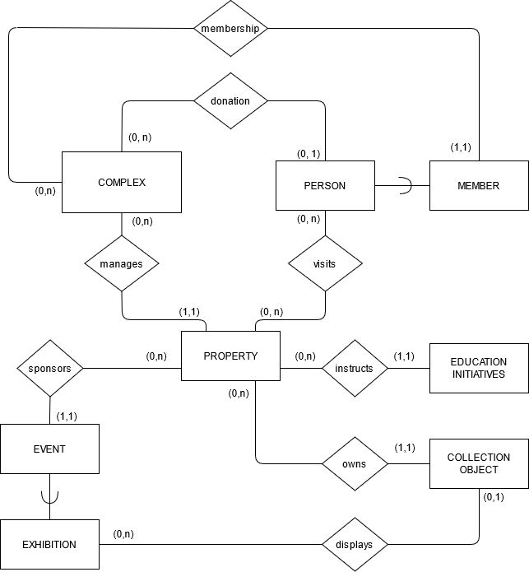

Figure 1: TSI Database conceptual database diagram

### 

### **3 Example Queries**

A list of some queries frequently asked about the data from the TSI database.

1. For a given PERSON, provide the list of all donations with COMPLEX.
2. Provide a list of all unique visits to COMPLEX PROPERTIES by a PERSON.
3. Provide a list of all PERSONS who are MEMBERS with COMPLEX.
4. Provide a list of PROPERTIES that are managed by COMPLEX.
5. For a certain subtype of PROPERTY, provide a list of all the PRNames of that subtype.
6. For each EDUCATION INITIATIVE, provide the EDDescription.
7. For a given PROPERTY, provide the current EVENTs EVName
8. For a given PROPERTY, provide the (PRAddress, Directions, VisitInfo, CurrentRestrictions, Map, FloorPlan)
9. Given COMPLEX, provide membership details and donation details from ComplexAbout.
10. Provide a list of all current MEMBERS, and their MembershipDetail.
11. Given a list of all current MEMBERS, provide statistics of current MEMBERS attributes inherited from PERSON.
12. Given COMPLEX, provide statistic from Publications
13. Given COMPLEX, provide statistics from PROPERTY managed by COMPLEX (ex. number of PROPERTIES managed by COMPLEX).
14. Given PROPERTY, provide statistics from relationships (ex. provide total number of objects from ItemName given COLLECTION owned by PROPERTY)

### 

### 

### 

### 

### 

### **4 The Logical Relational Schema (LRS) for the TSI database**

The conceptual schema described for The Smithsonian Institute database is mapped into the Relational Schema presented in this section. Primary keys are underlined. Domain constraints are listed after each attribute (attribute: domain data-type).

**COMPLEX**(ComplexName: string, ComplexAbout: string, PubName: string, PubDate: string, Author: string)

**PROPERTY**(PRName: string, PRDescription: string , PropertyType: string, VisitInfo:string , PRLink: string, PRStreet: string , PRCity: string, PRState: string, Highlights: string, PRMap: string, Floorplan: string, Transportation: string, Parking: string, EstablishmentName: string, CurrentRestrictions: string, Accessibility: string, ComplexName: string)

ComplexName is foreign key, references COMPLEX

**COLLECTION OBJECT**(ObjectRecordID: integer, ObjectName: string, ObjectType: string, ObjectDescription: string, ObjectKeywords: string, PRName: string)

PRName is foreign key, references *PROPERTY*

**PERSON**(FirstName: string, LastName: string, PerStreet: string, PerCity:string, PerState:string, PerPostalCode: string, EmailAddress: string, CreditCardNumber: string, Expiration: string, Seccode: string)

Additional domain constraints: PostalCode must be a string of numeric digits length 5.

CreditCard must be a string of numeric digits length 16.

Seccode must be a string of numeric digits length 3.

**VISIT**(FirstName: string, LastName: string, PerStreet: string, PRName: string)

{FirstName, LastName, PerStreet} is foreign key, references *PERSON*

PRName is foreign key, references *PROPERTY*

**MEMBER**(MemberNumber: integer, MemberLevel: string, ComplexName: string)

ComplexName is foreign key, references *COMPLEX*

**DONATION**(MemberNumber: integer, ComplexName: string, AmountDonated: real number)

MemberNumber is foreign key, references *MEMBER*

ComplexName is foreign key, references *COMPLEX*

**EVENT**(EVNumber: integer, EVName: string, EVDate: string, Location: string, AdmissionCost: real number, CoSponsor: string, Venue: string, EVDetails: string, Note: string, EVLink: string, PRName: string)

PRName is foreign key, references *PROPERTY*

**EXHIBITION**(EXNumber: integer, ExDescription: string, EVNumber: integer)

EVNumber is foreign key, references EVENT

**DISPLAYS**(ObjectRecordID: long integer, EXNumber: integer)

ObjectRecordID is foreign key, references *COLLECTION OBJECT*

EXNum is foreign key, references *EXHIBITION*

**EDUCATION INITIATIVE**(EDName: string, EDDescription: string, PRName: string)

PRName is foreign key, references *PROPERTY*

#### **4.1 Additional Integrity Constraints for the relational schema**

The integrity constraints must hold for The Smithsonian Institute database and that are not guaranteed by the relation schemas described above are listed in this subsection.

1. The relation COMPLEX for this relational model is a singleton instance with the ComplexName The Smithsonian Institute and is never null.
2. ComplexName in every instance of the relation PROPERTY must reference The Smithsonian Institute COMPLEX.
3. The EVNumber attribute cannot be null in EXHIBITION (EVENT is a supertype of exhibition and you cannot have an exhibition without an event).
4. These attributes may not be null due to minimum participation of 1:
   1. ComplexName in PROPERTY and MEMBER
   2. PRName in EVENT, COLLECTION OBJECT and EDUCATION INITIATIVE
5. Only one Event or Exhibition may be held at a certain Venue and EVDate at a time.
6. The PROPERTY attribute PropertyType can only assume the values of Cultural Center, Research Center, Zoo, Garden, Gallery, or Museum.
7. The COLLECTION OBJECT attribute ObjectType can only assume the values of cultural artifact, scientific artifact, historical artifact, animal or plant.